WSCRR’s Current Research
Notes in parentheses indicate whether the research activities listed are short duration projects or ongoing programs, funded (with dedicated funds from outside the AOC’s general fund allocations), and required (by law or by the Judiciary). “SAJE” refers to the Center for the Study and Advancement of Justice Effectiveness, the research collaboration among WSCCR, UW, and WSU.
- Adult Misdemeanor Offenses (project): WSCCR analysis of adults convicted of misdemeanors focuses on repeat offenders and substantial justice system and public safety costs. The goal is to identify sub-groups of chronic offenders who are good candidates for interventions intended to reduce offending. Staff: Andrew Peterson.
- Data Sharing (ONGOING): WSCCR maintains a set of high-value research data collections and routinely shares data for research purposes. WSCCR also uses data shared with it by courts and other agencies. WSCCR currently has 27 active and 5 pending data sharing agreements with diverse organizations such as the University of Southern California, the National Center for Juvenile Justice, and WA DSHS. Staff: Rachael Sanford, Carl McCurley.
- Dependency
  - Trained Attorneys to Represent Children (project, funded): In 2017, the Legislature funded the Office of Civil Legal Aid to pilot child representation programs and required an evaluation of the effects of the pilot on court process and child outcomes. WSCCR funding is from July, 2018 through June, 2019. Staff: Carl McCurley.
  - WA Dependency Performance Reporting System (required, federal grant): WSCCR and Children’s Administration partner to build enhanced dependency records and WSCCR produces the online Interactive Dependency Timeliness Report (iDTR) and annual reports to the Legislature on dependency case timeliness and outcomes. WSCCR provides monthly data to members of all key elements of case handling—judges, Children’s Administration, the Office of Public Defense, and others. WSCCR works with Family and Juvenile Court coordinators and the Court Improvement Training Academy to help courts engage with the data and develop practice improvements. In the last year a Dependency Dashboard was developed; a public-facing site with current, point-in-time dependency data by county. Staff: Matt Orme, Wei Wang, Rachael Sanford.
- Judicial Need Estimates and Court Staffing Report (required, ONGOING): Annual estimates of the number of judicial officers required in each court utilizing an objective, quantified, workload analysis model. Staff: Wei Wang, Carl McCurley.
  - Enhancements for District and Municipal Courts (ONGOING): WSCCR and other AOC staff joined with a DMCJA work group to create new ways to record different hearing types, such as hearings in treatment court, that were not formerly distinguishable in the Judicial Information System (JIS). Analysis of the new information will provide the courts with a better understanding of how needs vary with the types of hearings held by particular courts.

- Education Achievement and Outcomes for Court-Involved youth (funded, project): A four-year project to develop reporting that provides courts, schools and other stakeholders with relevant facts about the risks to education faced by court-involved youth. Staff: Arina Gertseva, Wei Wang, Carl McCurley.
- Juvenile Detention
  - Detention Center Profiles (project): To inform planning and improve understanding of operations and effects on youth who experience confinement, the Juvenile Court Administrators have asked that WSCCR develop an inventory of process and programs in Washington’s 22 juvenile detention centers. Staff: Amanda Gilman, Rachael Sanford.
  - Evaluation of Juvenile Detention Alternatives Initiative (JDAI) in WA (funded, project): WSCCR and UW’s Evidence-Based Practices Institute are evaluating the national Juvenile Detention Alternatives Initiative as implemented in Washington State. Funded by the Annie E. Casey Foundation. Staff: Amanda Gilman.
  - Juvenile Detention Alternatives Initiative Performance Reporting (funded, ONGOING): The Office of Juvenile Justice contracts with WSCCR to provide quarterly and annual performance information related to the use of detention by courts that participate in the Initiative. Staff: Amanda Gilman, Rachael Sanford.
  - Statewide Reporting (required, ONGOING): 2016 session law requires AOC to collect and analyze data on all juvenile detention admissions and to report annually to the Legislature on the characteristics of youth admitted to detention, with emphasis on the use of detention in civil cases (such as truancy). Staff: Amanda Gilman, Rachael Sanford, Wei Wang.
- Juvenile Probation
  - Case Management Assessment Processes (CMAP) QA (funded, ONGOING): CMAP is a comprehensive program to engage with youth, assess recidivism risk and criminogenic needs, guide case planning, and support pro-social change. CMAP operates in all 33 juvenile courts. WSCCR and the juvenile courts work to update CMAP by reviewing research and borrowing from effective practices in other states and nations. Staff: David Sattler, Stephanie Ballou.
  - Evaluation design (funded, SAJE project): The committee that oversees funding for treatment programs has asked WSCCR to create study designs to guide future evaluations of treatment program innovations, such as a version of Aggression Replacement Training shortened from 10 weeks to 8 weeks. Staff: Carl McCurley, Amanda Gilman.
  - Performance Reporting (required, funded, ONGOING): Reports the results from analysis of youth characteristics (age, race, gender, risk level), eligibility for and participation in treatment programs, intermediate and recidivism outcomes. Helps courts understand treatment program utilization and effectiveness and make changes for improvement. Staff: Arina Gertseva, David Sattler.
  - Program Implementation Review and Feedback (ONGOING): WSCCR works with the juvenile courts to develop and implement a quality assessment process to improve the effectiveness of probation supervision and its support of treatment programs. Staff: Amanda Gilman, David Sattler, Rachael Sanford, Carl McCurley.
- Juvenile Probation (continued)
  - Responsivity Analysis (SAJE project): A major but unanswered question is “Are youth being assigned to programs that are the best fit for improving behavior?” WSCCR works alongside researchers at WSU to improve identification of youth likely to benefit from particular interventions. Staff: Andrew Peterson, Wei Wang, Carl McCurley.
  - Step-Up Evaluation (funded, project): With UW’s Evidence-Based Practice Institute, WSCCR is evaluating the effectiveness of Step-Up, an intervention intended to address youth violence toward family members. Staff: Amanda Gilman.
  - Treatment Provider Rating Instrument (funded, SAJE project): The committee that oversees funding for treatment programs has asked WSCCR to devise and test a rating tool that can be used to grade the quality of the most frequently used evidence-based program, Aggression Replacement Training. Staff: Carl McCurley.
  - Treatment System Reform (project): UW’s Evidence-Based Practice Institute and WSCCR have proposed modernized rules to govern local court access to and control over state-funded treatment programs with the aim of making such programs easier to adopt, more adaptable to local conditions, and easier to monitor and manage for improved results over time. Staff: Carl McCurley.
  - Trauma Histories among First-Time Probationers (project): WSCCR has partnered with a colleague from the University of Southern California’s School of Social Work to examine the prevalence, nature, and consequences of trauma histories among youth starting probation for the first time. Staff: Amanda Gilman.
  - Gender-responsive practices (project): In support of gender-responsive practices, WSCCR initiated reporting on the needs, challenges, and intervention outcomes of girls entering the probation in the state of Washington. This reporting serves as a research foundation to help courts make sound decisions about how to respond to the girls coming to juvenile probation. Staff: Arina Gertseva.
- Recidivism Reporting (ONGOING): WSCCR and the National Center for Juvenile Justice have developed for Washington reporting at the county- and state-level showing recidivism rates for youth with juvenile court dispositions. Now adding adult criminal cases. An important measure of justice system effectiveness, recidivism reporting should be routine for juvenile, adult, and treatment courts. Staff: Andrew Peterson.
- Research Databases (required, ONGOING): WSCCR maintains data resources necessary to a broad range of planning, development, and research and evaluation efforts. An example is the Court Contact and Recidivism Database (CCRD), which contains individuals’ charge-level court records from juvenile court, dependencies, and adult criminal court. Staff: Wei Wang, Andrew Peterson, Amanda Gilman, Arina Gertseva, David Sattler, Carl McCurley.
- Court-Research Colloquia (SAJE project): The Juvenile Court Administrators and, separately, the Juvenile Probation Managers ask that SAJE deliver presentations and lead discussions at their conferences about research findings relevant to juvenile court operations. Staff: Carl McCurley, Amanda Gilman, Andrew Peterson.
- Statistical Briefing Book (SAJE project): WSCCR and WSU are developing basic reporting on the number and type of cases that enter the courts and their outcomes in a given year. This reporting will include breakouts for race/ethnicity, gender, age, county, and offense type, and will cover both juvenile and adult cases. Staff: Andrew Peterson.
- Survey Methodology Training (ONGOING): WSCCR is developing training on survey preparation, design and conceptualization, piloting, sampling, response rate, data collection and logistics, and data analyses. A survey methodology workshop was approved. The purpose is to train all AOC staff who develop surveys on how to develop a good survey. Staff: Arina Gertseva.
- Youth Homelessness Risk Screener and Response (funded, SAJE project): The Raikes and Block foundations support the SAJE Center to develop and validate a screening instrument that can be used by Juvenile Courts and other youth-serving systems (such as schools, health care providers, and others) to assess youths’ risk for homelessness. SAJE is also working with the Juvenile Court, detention centers, jails, shelter and housing providers, and other community partners in Kitsap and Snohomish Counties to create connections and procedures that prevent youth and young adults from exiting confinement into homelessness. Staff: Carl McCurley, Andrew Peterson.
- Use of Research and Data Grant Application (SAJE project): After an application to the William T. Grant Foundation for funding to address racial and ethnic disparity in juvenile justice failed to win approval, the Foundation provided specific direction on how to reshape the application and invited a resubmission. The proposal is being revised to have a narrower focus on ways to increase the uptake and use of research information by court staff, especially mid-level managers. Staff: Carl McCurley, Andrew Peterson.

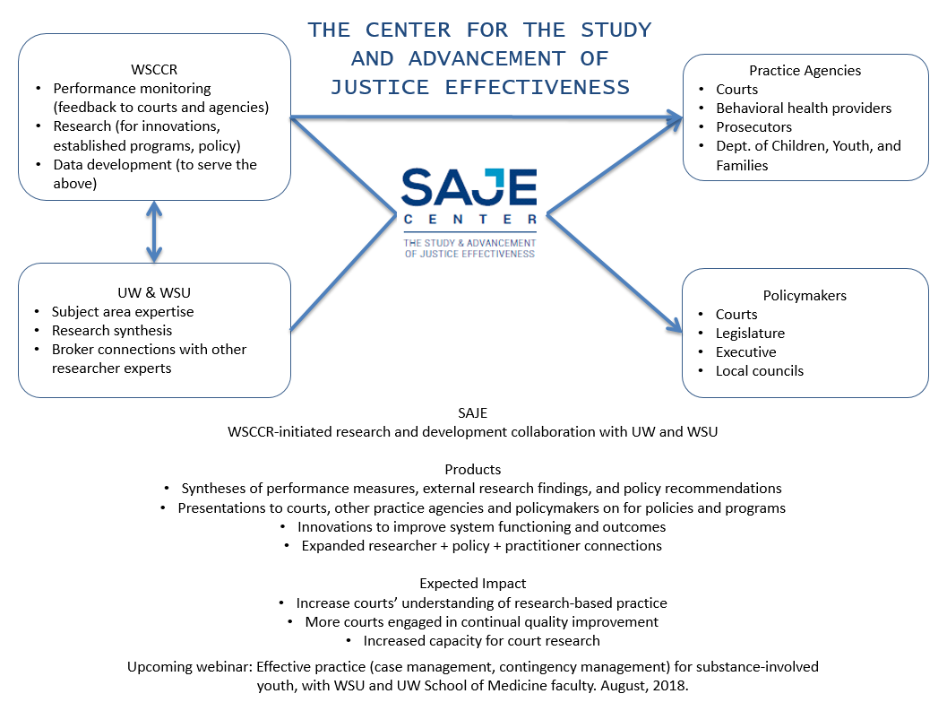

WSCCR Staffing

WSCCR has eight full-time and one part-time staff members. Of the five WSCCR researchers, two are state-funded through the AOC and can be assigned in response to judicial branch priorities.
Name | Job Title | Funding | Assignable?
RESEARCHERS
Arina Gertseva, Ph.D. | Senior research associate—Juvenile Probation, Schools & Courts research | 0.4 FTE juvenile courts, 0.4 FTE Federal grant, 0.2 RW Johnson Foundation | No
Amanda Gilman, Ph.D. | Senior research associate | general fund, 0.2 other state funds | Yes
Matthew Orme, M.F.A. | Senior research associate—Dependencies | Federal grant | No
Andrew Peterson, Ph.D. | Senior research associate | general fund | Yes
Rachael Sanford | Research assistant | general fund, 0.8 other state funds | No
OTHER STAFF
Stephanie Ballou | Quality assurance administrative assistant | DSHS | n/a
Carl McCurley, Ph.D. | Research manager | AOC state general fund | n/a
David Sattler, M.A. | Quality assurance coordinator | DSHS | n/a
Wei Wang, M.S. | Systems integrator (data extraction, transformation, merging) | general fund | n/a

WSCCR Committee Assignments

WSCCR staff provide expert guidance, research translation, and research to—
- Becca Task Force (member): Statewide collaboration of professionals interested in positive outcomes for youth who are engaged in the Becca petition process. Staff: Carl McCurley, Amanda Gilman, Arina Gertseva.
- Block Grant Oversight Committee (member): Considers funding and accountability for Juvenile Courts receiving state funding for treatment programs. Staff: Carl McCurley.
- Center for the Study and Advancement of Justice Effectiveness (SAJE) Directors (member) and SAJE Advisors Committee (staff): Directors meet weekly to coordinate and plan. Advisors meet quarterly to inform the directors of emerging needs and opportunities for court-related research and to help make connections to funding. Staff: Carl McCurley.
- Community Juvenile Accountability Act (member): Oversight and improvement of state-funded evidence-based treatment programs for juvenile offenders. Staff: Carl McCurley, David Sattler, Amanda Gilman.
- Court Improvement Program State Oversight Committee (member): For dependency cases. Staff: Matt Orme, Carl McCurley.
- Domestic Violence Work Group (member): An initiative of the Gender and Justice Commission to improve Washington Courts’ response to domestic violence by designing a model program structure. Staff: Carl McCurley.
- Juvenile Detention Alternatives Initiative (JDAI) Steering Committee (member) and JDAI data work group (chair): Implementation of the initiative and data validation, improvement, and reporting. Staff: Amanda Gilman.
- Juvenile Probation Quality Assurance Committee (member): QA and program improvement for juvenile probation and the juvenile risk/needs assessment. Staff: David Sattler.
- Pretrial Reform Taskforce (member): Statewide collaboration of court actors, treatment providers, and industry professionals, examining the current state of the pretrial process in Washington State and looking for ways to reduce costs, improve efficiency, all while maintaining or reducing new criminal activity while on release and failures to appear. Staff: Andrew Peterson.
- Trial Court Sentencing and Supervision (staff support): Use of the Adult Static Risk Assessment for pretrial / first appearance and Interpret research findings related to offender risk, needs, and failure to appear screening and assessment. Staff: Andrew Peterson.

